**ASSIGNMENT 4**

|  |  |
| --- | --- |
| **Date** | 11 Nov 22 |
| **Name** | Santhosh S |
| **Team ID** | PNT2022TMID38287 |
| **Project Name** | IOT Based Smart Solution  for Railways |

**QUESTION:**

Write code and connection in wovki for ultrasonic sensor. Whenever distance is less than 100 cms send “alert” to IBM cloud and display in device recent events

**CODE:**

#include <WiFi.h>//library for wifi

#include <PubSubClient.h>//library for MQtt

WiFiClient wifiClient;

String data3;

#define ORG "xaiasf"

#define DEVICE_TYPE "santhosh"

#define DEVICE_ID "assignment_4"

#define TOKEN "12345678"

#define speed 0.034

#define led 14

char server[] = ORG ".messaging.internetofthings.ibmcloud.com";

char publishTopic[] = "iot-2/evt/santhosh/fmt/json";

char topic[] = "iot-2/cmd/event_1/fmt/String";

char authMethod[] = "use-token-auth";

char token[] = TOKEN;

char clientId[] = "d:" ORG ":" DEVICE_TYPE ":" DEVICE_ID;

PubSubClient client(server, 1883, wifiClient);

const int trigpin=5;

const int echopin=18;

String command;

String data="";

long duration;

float dist;

void setup()

{

**Serial**.begin(115200);

pinMode(led, OUTPUT);

pinMode(trigpin, OUTPUT);

pinMode(echopin, INPUT);

wifiConnect();

mqttConnect();

}

void loop(){

  bool isNearby = dist < 100;

  digitalWrite(led, isNearby);

publishData();

delay(500);

if (!client.loop()){

  mqttConnect();

}

}

void wifiConnect(){

**Serial**.print("Connecting to "); **Serial**.print("Wifi");

  WiFi.begin("Wokwi-GUEST", "", 6);

  while (WiFi.status() != WL_CONNECTED){

    delay(500);

**Serial**.print(".");

  }

**Serial**.print("WiFi connected, IP address: "); **Serial**.println(WiFi.localIP());

}

void mqttConnect(){

  if (!client.connected()){

**Serial**.print("Reconnecting MQTT client to "); **Serial**.println(server);

    while (!client.connect(clientId, authMethod, token)){

**Serial**.print(".");

      delay(500);

    }

    initManagedDevice();

**Serial**.println();

  }

}

void initManagedDevice() {

  if (client.subscribe(topic)){

    // Serial.println(client.subscribe(topic));

**Serial**.println("IBM subscribe to cmd OK");

    }

else{

**Serial**.println("subscribe to cmd FAILED");

  }

}

void publishData(){

  digitalWrite(trigpin,LOW);

  digitalWrite(trigpin,HIGH);

  delayMicroseconds(10);

  digitalWrite(trigpin,LOW);

  duration=pulseIn(echopin,HIGH);

  dist=duration*speed/2;

  if(dist<100){

    String payload = "{\"Alert Distance\":";

    payload += dist;

    payload += "}";

**Serial**.print("\n");

**Serial**.print("Sending payload: ");

**Serial**.println(payload);

    if (client.publish(publishTopic, (char*) payload.c_str())){

**Serial**.println("Publish OK");

    }

  }

  if(dist>100){

    String payload = "{\"Distance\":";

    payload += dist;

    payload += "}";

**Serial**.print("\n");

**Serial**.print("Sending payload: ");

**Serial**.println(payload);

    if(client.publish(publishTopic, (char*) payload.c_str())){

**Serial**.println("Publish OK");

    }

 else{

**Serial**.println("Publish FAILED");

   }

  }

}

**OUTPUT :**

1. When Distance greater than 100 cm

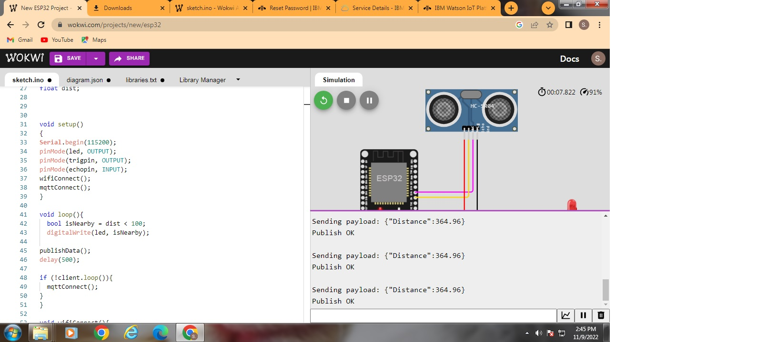

IBM RECENT EVENTS

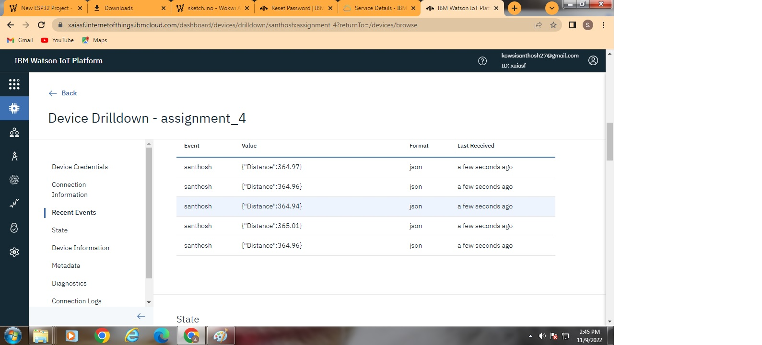

1. When distance less than 100

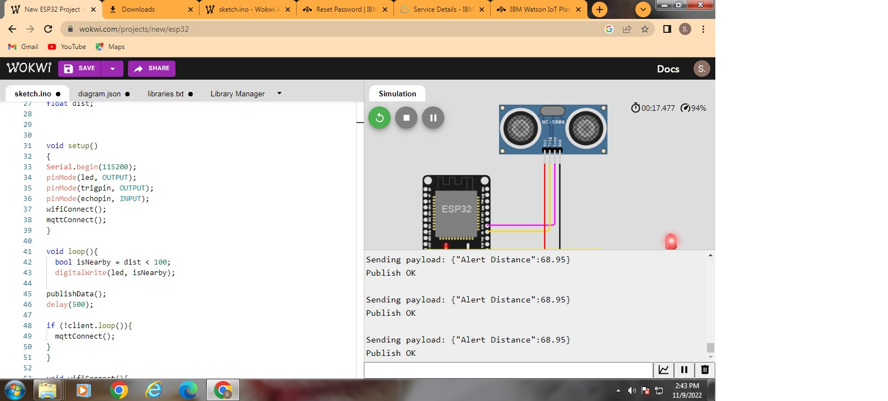

**IBM RECENT EVENTS**

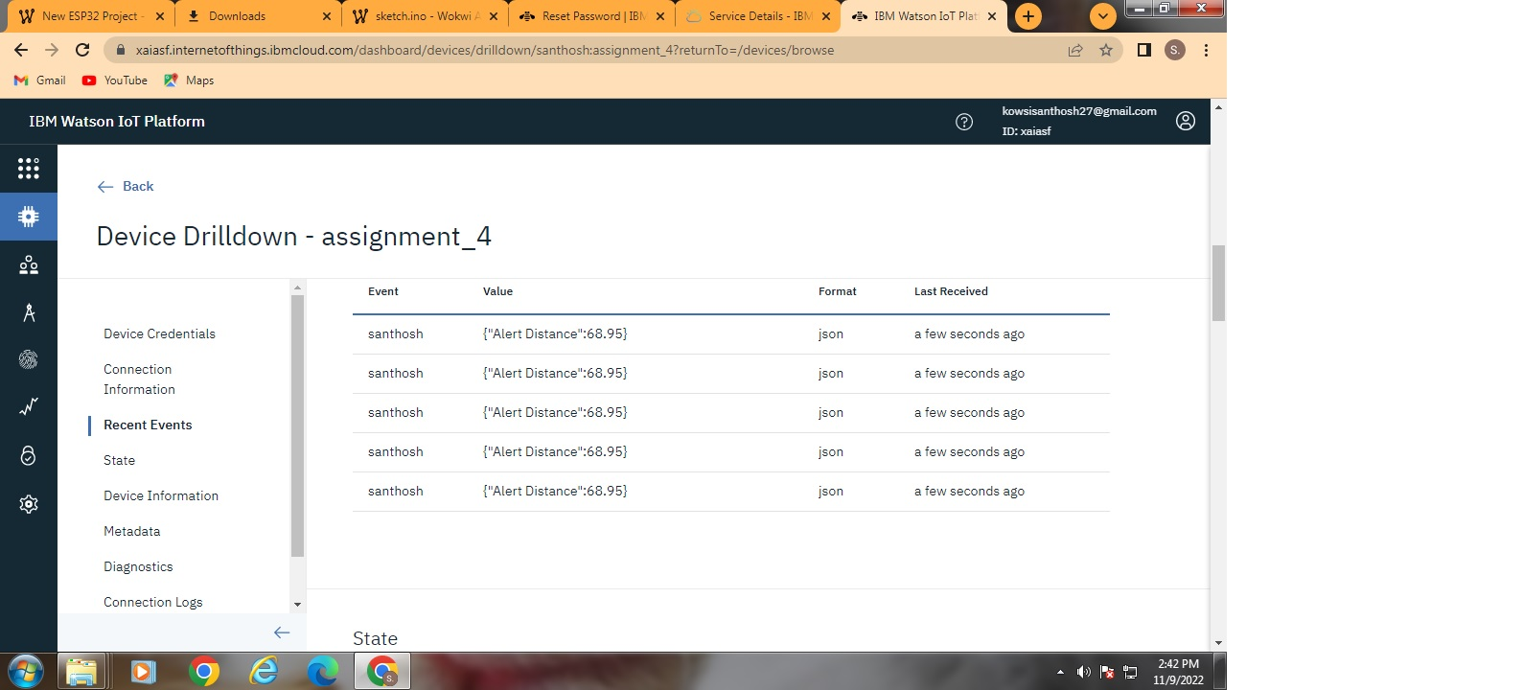

**WOVKI LINK-** [**https://wokwi.com/projects/346563506325160531**](https://wokwi.com/projects/346563506325160531)